**IMAGE AND VIDEO ANALYTICS**

**LAB ASSESMENT – 5**

**Student Name:** DIVYA SANKARI S **Course:** Image and Video Analytics

**Reg No:** 21MIA1083  **Submission Date:** 23/10/2024

**Submitted to:** Dr. Saranyaraj D

**OBJECTIVE :**

**Task1:** Detect motion and specific events in a video using frame differencing or optical flow to estimate motion and identify events without machine learning.

**Task2**:Estimate the sentiments of individuals in a crowd using basic gesture analysis techniques, such as detecting facial expressions or hand gestures, without using machine learning models.

**Task3:** Identify the gender of individuals based on facial features using traditional image processing and feature extraction techniques without using machine learning models.

**PROBLEM STATEMENT:**

The goal is to detect and highlight motion within a video stream by analyzing consecutive frames for significant changes. We will identify moments of intense activity or sudden movements and visualize these events.

**Pseudo-code**

**Task1:**

Load Video

* Initialize video capture.
* Read frames in a loop until the end of the video.
* Motion Estimation

For each frame:

* Convert the current frame and the previous frame to grayscale.
* Compute the absolute difference between consecutive frames.
* Apply thresholding to highlight significant motion regions.
* Use contour detection to identify moving objects.
* Event Detection

For each frame, analyze the intensity of motion:

* If motion intensity exceeds a certain threshold, mark the frame as an event.
* Store timestamps and mark the frames.

Visualization

* Annotate frames with detected motion.
* Save or display the annotated frames.

**ALGORITHM:**

Load video using OpenCV.

Initialize the previous frame as None.

Loop through each frame:

Convert frames to grayscale.

Compute the difference between the current and previous frames.

Apply a Gaussian blur to reduce noise.

Threshold the result to create a binary image.

Find contours in the binary image.

If significant contours are found, mark the frame as an event.

Save annotated frames with timestamps.

**RESULTS AND CONCLUSION:**

The output will include visualized frames highlighting moving regions and annotated timestamps of detected event.The approach provides a simple yet effective means of detecting motion and identifying significant events without relying on complex machine learning models, offering potential applications in surveillance and monitoring systems.

**Discussion**

* The effectiveness of frame differencing in detecting motion relies on consistent lighting and minimal background changes.
* More complex scenarios (e.g., multiple moving objects) may require additional preprocessing steps to filter out noise.

**OUTPUT:**

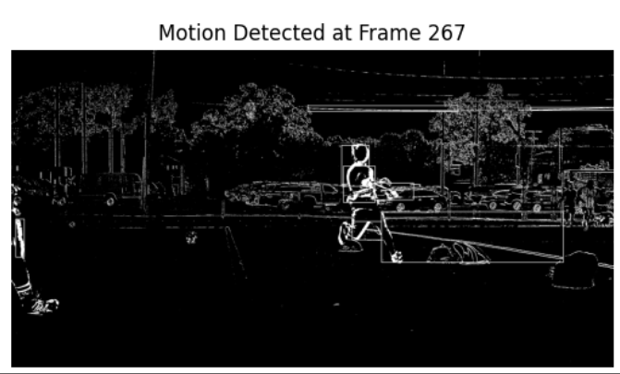

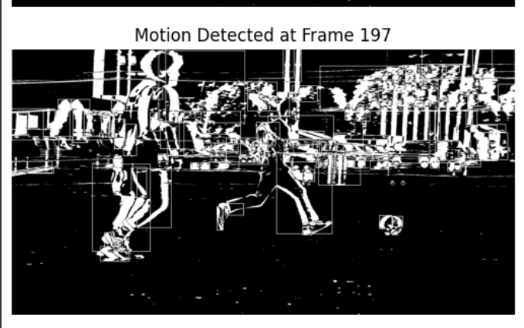

**OBJECTIVE :**

**Task2**:Estimate the sentiments of individuals in a crowd using basic gesture analysis techniques, such as detecting facial expressions or hand gestures, without using machine learning models.

**PROBLEM STATEMENT:**

To analyze facial expressions and gestures of individuals in crowd images to estimate their sentiments (happy, sad, neutral) and categorize the overall sentiment of the crowd.

**Pseudo-code:**

Load Image Set

* Load images from the provided dataset.
* Preprocessing

Detect faces using skin-color-based detection.

* Extract the regions of detected faces.
* Gesture Analysis

For each detected face:

* Analyze facial geometry to identify key features (eyes, mouth, eyebrows).
* Classify emotions based on facial expressions:
* Happiness: upward mouth curvature.
* Sadness: downward mouth curvature.

Image Categorization

* Aggregate sentiments of all detected individuals.
* Determine the overall sentiment of the crowd.

Output Results

* Display individual sentiments and overall crowd sentiment.
* Annotate images with detected features.

**ALGORITHM:**

* Load images from the dataset.
* For each image:
* Use color thresholding to detect skin areas.
* Apply contour detection to identify facial features.
* Analyze geometrical features to classify emotions.
* Count the number of individuals per sentiment.
* Display results and key features for each image.

**RESULTS AND CONCLUSION:**

This method offers an accessible way to gauge sentiment in crowds without complex models, but its accuracy can be limited by environmental factors. The output will include sentiment estimates for each individual and an overall sentiment categorization for the crowd.

**Discussion**

The approach relies on simple geometric calculations and may miss subtler emotions.

It may struggle with occlusions and varied lighting conditions, affecting the accuracy of gesture detection.

**OUTPUT:**

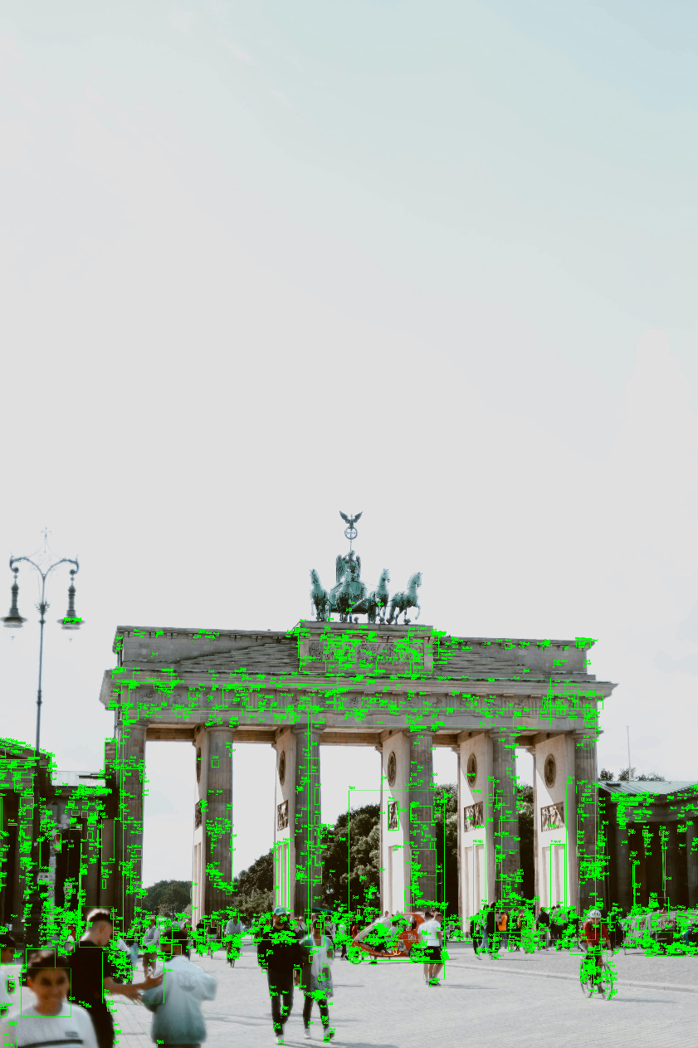

**OBJECTIVE :**

**Task3:** Identify the gender of individuals based on facial features using traditional image processing and feature extraction techniques without using machine learning models.

**PROBLEM STATEMENT:**

To determine the gender of individuals in a dataset of facial images by analyzing geometric and texture features without using machine learning models.

**Pseudo-code**

Load Dataset

* Load images labeled by gender.
* Preprocessing

Detect faces in images using Haar cascades.

Normalize and crop the facial regions.

Feature Extraction

* Extract geometric features (distances between eyes, jawline width).
* Extract texture features (using LBP or edge detection).

Rule-Based Gender Identification

Use predefined rules:

* Compare jawline width and texture.
* Classify as Male or Female based on extracted features.
* Output Results

Display identified gender for each image.

Visualize and explain extracted features.

**ALGORITHM:**

Load facial images.

For each image:

Use Haar cascades to detect faces.

Calculate geometric and texture features.

Apply rule-based classification based on extracted features.

Output identified genders and feature visualizations.

**RESULTS AND CONCLUSION:**

The output will include the identified gender for each image along with visual explanations of the features leading to the classification.

**Discussion**

The method relies on defined rules, which may lead to misclassifications, particularly for androgynous faces or varied ethnicities.

This approach may need further refinement to improve accuracy and robustness

**OUTPUT**

This task demonstrates a straightforward technique for gender identification based on facial features, offering insights into traditional image processing without the complexity of machine learning models.



**GitHub link :**

https://github.com/DivyaSankari/TASK5-IVA